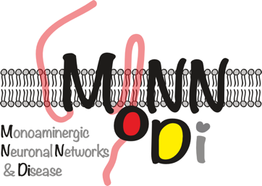
Application Form

PhD-Position at the RTG “Monoaminergic Neuronal Networks & Disease (MoNN&Di)” at the Ruhr-Uni-Bochum
Submit to:
monndi@rub.de

For more information:
www.ruhr-uni-bochum.de/monndi/
First name:
Last name:
Mobile phone:
Email:
Private address:

Which PhD project are you applying for?
1. Choice: PhD-Project number and PI:
2. Choice: PhD-Project number and PI:

BA-Information
Bachelor Program with title:
Bachelor Degree received:
Date (Month/Year):
University:
Title of Bachelor Essay:
with grade:

MA/Diploma (or equivalent)-Information
Master Program with title:
Master Degree received:
Date (Month/Year):
University:
Title of Master Essay:
First Supervisor:
with grade:

Publication in peer-reviewed journal (full reference if available):

Awards/Grants:

List two possible referees (letters of recommendation can be requested from):
Name:
Email:
Name:
Email:

Additional remarks about special competences relevant for the PhD-project:

Remark: We guarantee that only the committee members of the RTG and the university administration, responsible for realizing a position, have access to the private information.

