Electropherogram total RNA:

PanIN2 Pool total RNA (4000 cells)
→ mRNA-Pico-2003-06-03.cld

c = 3.0 ng/µl
→ 34.1 ng ≙ 1000 cells

Electropherogram aRNA:

→ 2 one-round amplifications were performed in parallel on 34.1 ng of total RNA each
→ mRNA-Pico-2003-06-06.cld (Proben 4-6 und 9)

c = 6.6 ng/µl
total yield: 1325 ng

Agarose gel of cDNA first strand synthesis:

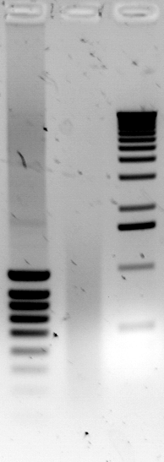 | Spur: | Probe:
 | 1 | 2 µl Smart Ladder SF (Eurogentec)
 | 2 | 0.5 µl first strand synthesis (of 21.5 µl)
 | 3 | 10 µl 1kb Ladder
1% Agarosegel
Aperture: 1.8
Exposition time: 680 ms

SAGE-Test-PCRs:

- 10 µl Test-PCR on a 1% agarose gel
- positive control: BXPC3 cDNA
- negative control: loTE instead of template
- upper picture: 25 cycles (Aperture 1.8 / Exposition time 800 ms)
- lower picture: 35 cycles (Aperture 1.8 Exposition time 800 ms)

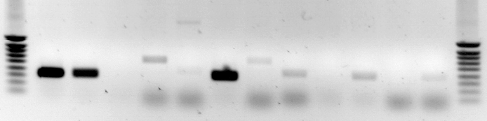 | Lane | Sample
 | 1 | 2 µl Smart Ladder SF
 | 2 | Efα positive control
 | 3 | Efα SAGE-cDNA
 | 4 | Efα negative control
 | 5 | GAPDH SAGE-cDNA
 | 6 | GAPDH negative control
 | 7 | Efα_SAGE∆Hsp92II
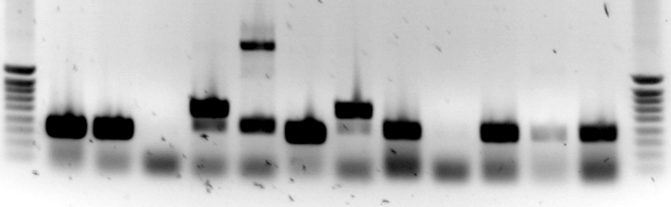 | 8 | GAPDH_SAGE∆Hsp92II
 | 9 | Lig1 positive
 | 10 | Lig1 negative
 | 11 | Lig2 positive
 | 12 | Lig2 negative
 | 13 | Mme I
 | 14 | 2 µl Smart Ladder SF

Ditag-Test-PCR:

- 5 µl PCR producto on a 12% polyacrylamide gel (19:1)
- positive control: former SAGE library

EMBED CorelPhotoPaint.Image.8 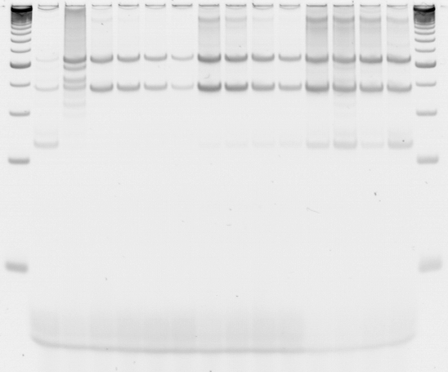 | Lane | Sample
 | 1 | 10 µl 25 bp Ladder
 | 2 | negative contr.: LIG-, 1:50, 31 Zyklen
 | 3 | positive control
 | 4-7 | LIG+, 1:50/1:100/1:200/1:400,  26 Zyklen
 | 8-11 | LIG+, 1:50/1:100/1:200/1:400,  28 Zyklen
 | 12-15 | LIG+, 1:50/1:100/1:200/1:400,  31 Zyklen
 | 16 | 10 µl 25 bp Ladder
Aperture: 1.8
Exposition time: 360 ms

large scale PCRΔHsp92 II:
12% polyacrylamide gel, 19:1

EMBED CorelPhotoPaint.Image.8 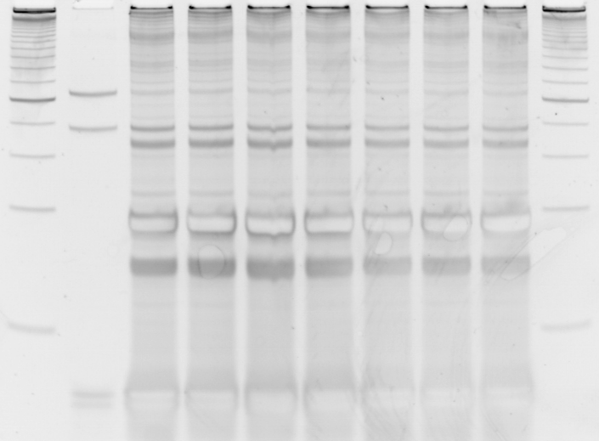 | Lane | Sample
 | 1 | 10 µl 25 bp Ladder
 | 2 | 5 µl lsPCR*
 | 3-10 | lsPCR∆Hsp92 II
* sample taken before Hsp92 II digestion

Aperture: 1.8
Exposition time: 520 ms

EMBED CorelPhotoPaint.Image.8

Concatemers:

EMBED CorelPhotoPaint.Image.8 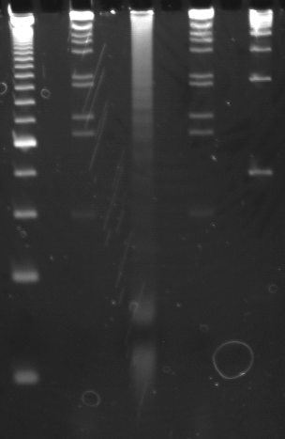§ | EMBED CorelPhotoPaint.Image.8 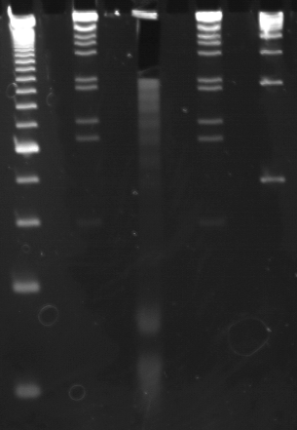 | Lane | Sample
 |  | 1 | 10 µl 25 bp Ladder
 |  | 2 | 10 µl 1 kb Ladder
 |  | 3 | Concatemers
 |  | 4 | 10 µl 1 kb Ladder
 |  | 5 | 2 µl Smart Ladder SF
8% Polyacrylamide gel, 19:1
Aperture: 1.8
Exposition time: 800 ms

Insert-PCR:

1,5% agarose gel:
- 3 µl PCR product each

EMBED CorelDraw.Graphic.8

green line: PCR products >600 bp contain inserts >270 bp (majority of PCR products should
be >600 bp)
red line: PCR products <400 bp don´t contain insert (empty vector gives a 330 bp PCR
product)

→ this library contains a rather high percentage of empty vectors (normally we don´t get empty vectors in the insert-PCR but the pZERO vectro can be tricky) but it was nevertheless used for sequencing

